* **Name of the Activity**: Two-day International Seminar on “Rammohan O Vidyasagar: Ekusher Bhabnai.
* **Type of the Activity**: Seminar
* **Organizing Department**: Department of Bengali
* **Date and time of the Activity**: 27.08.2019-28.08.2019 from 1.30 pm – 3.30 pm (IST)
* **Number of participants**: 51
* **Speakers**:
  + Abul Ahsan Chowdhury, Ex-Professor in Islamic University, Kushtia, Bangladesh and ‘Lalon expert’
  + Dr. Ratan Kumar Nandi, Secretary, Bangiyo Sahitya Parishad
  + Dr. Tapan Bagchi, Bangla Academy, Dhaka
  + Dr. Sabitri Nanda Chakraborty, Professor, Department of Bengali, K.U. and some other renowned dignitaries
* **Photograph of the Programme**:

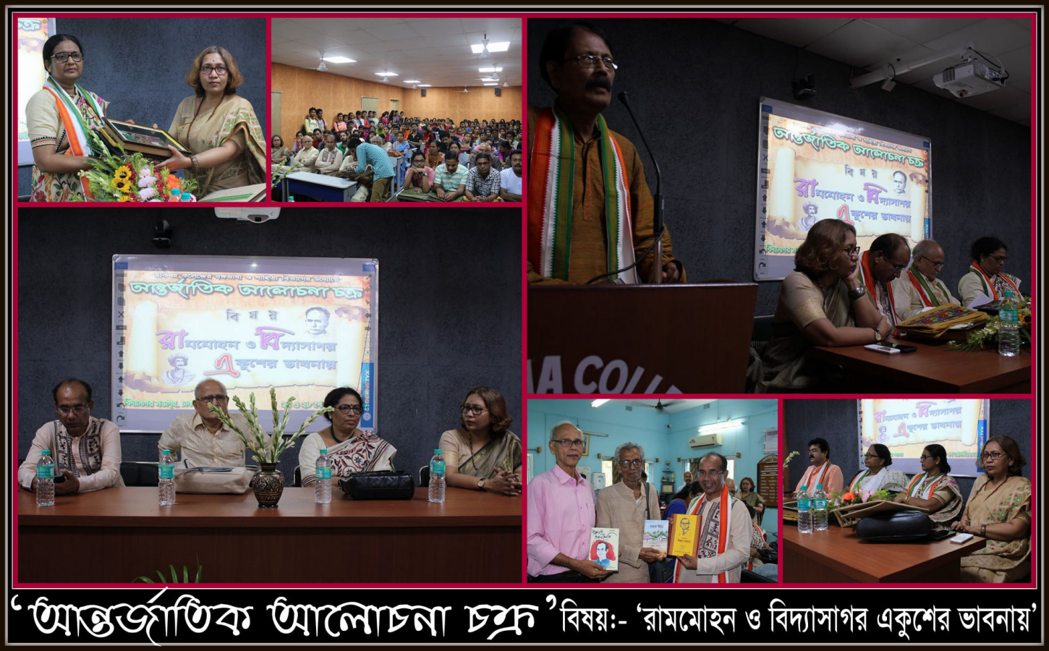

**Attendance:**

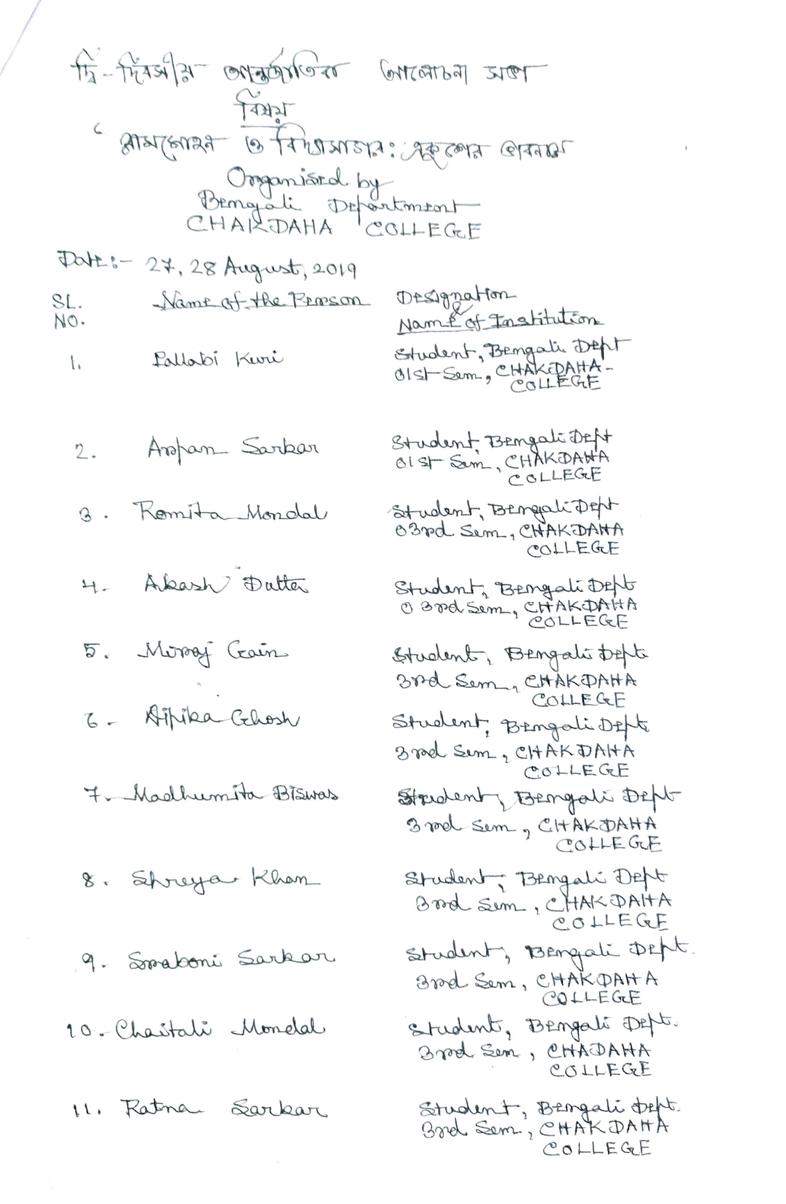

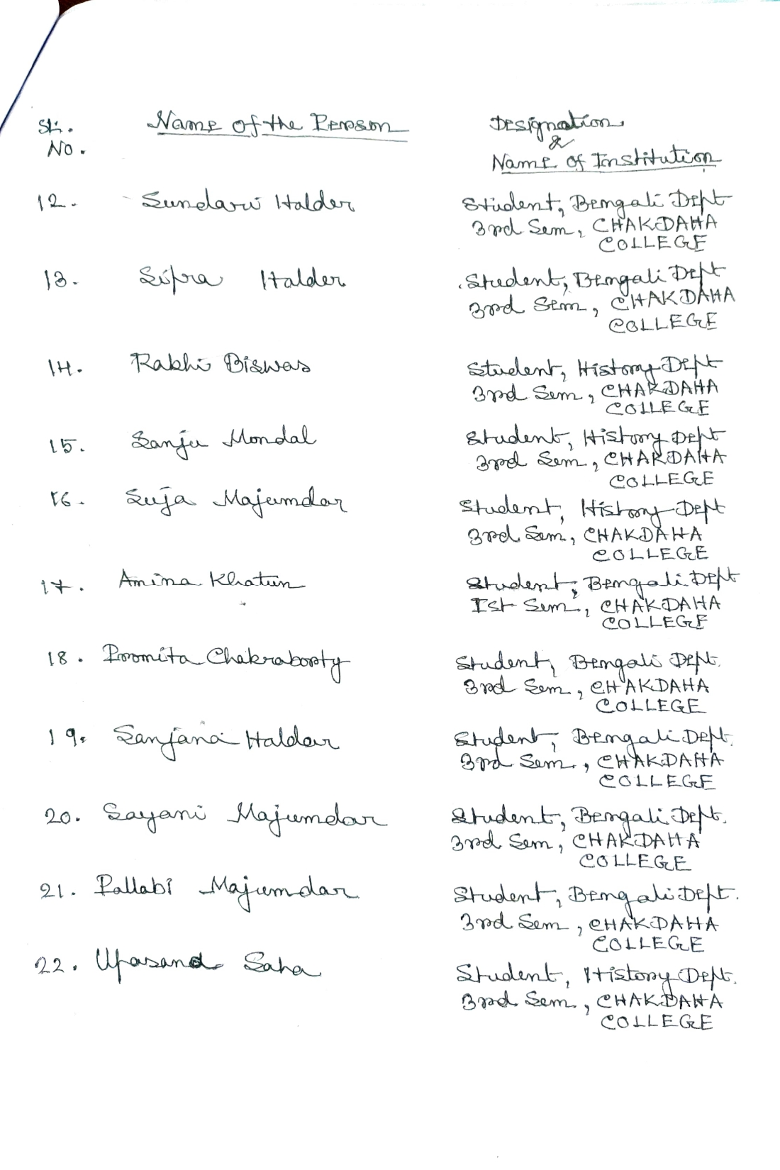

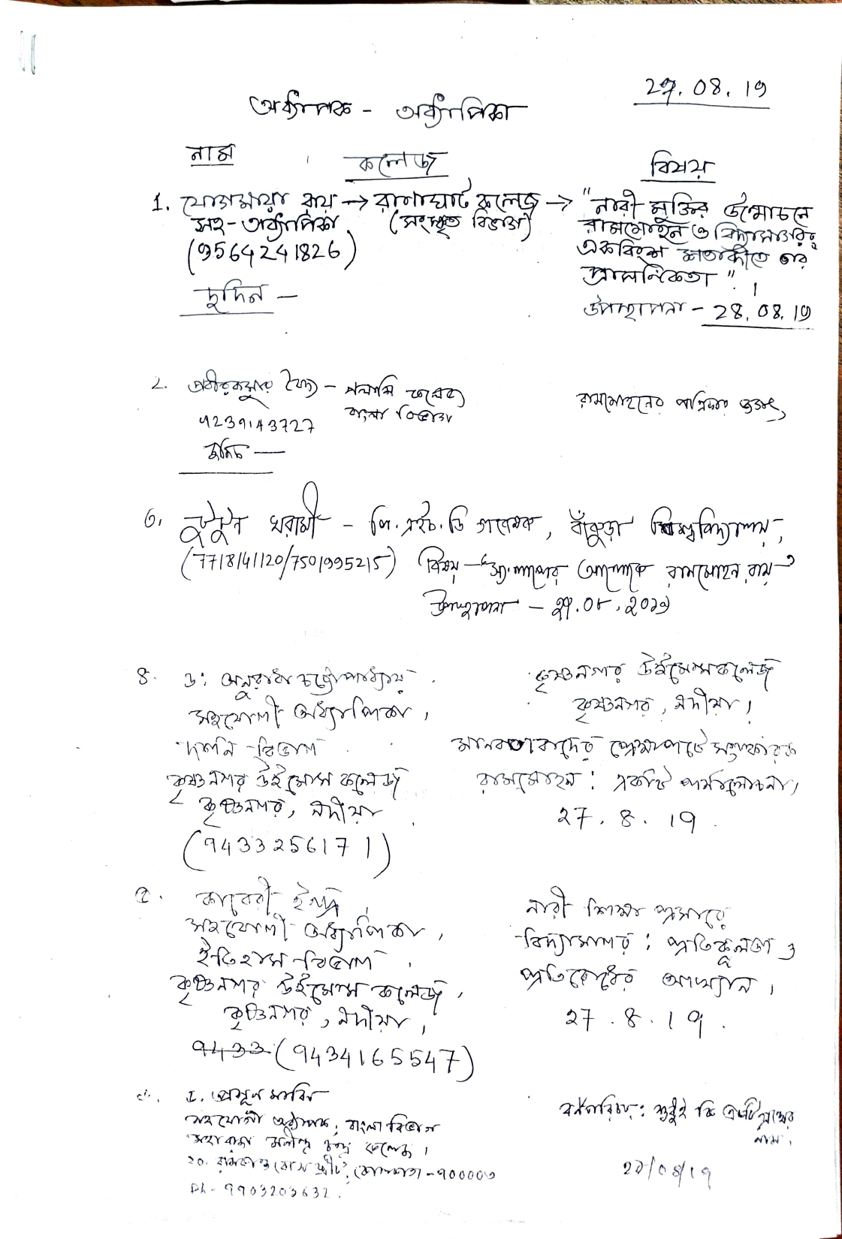

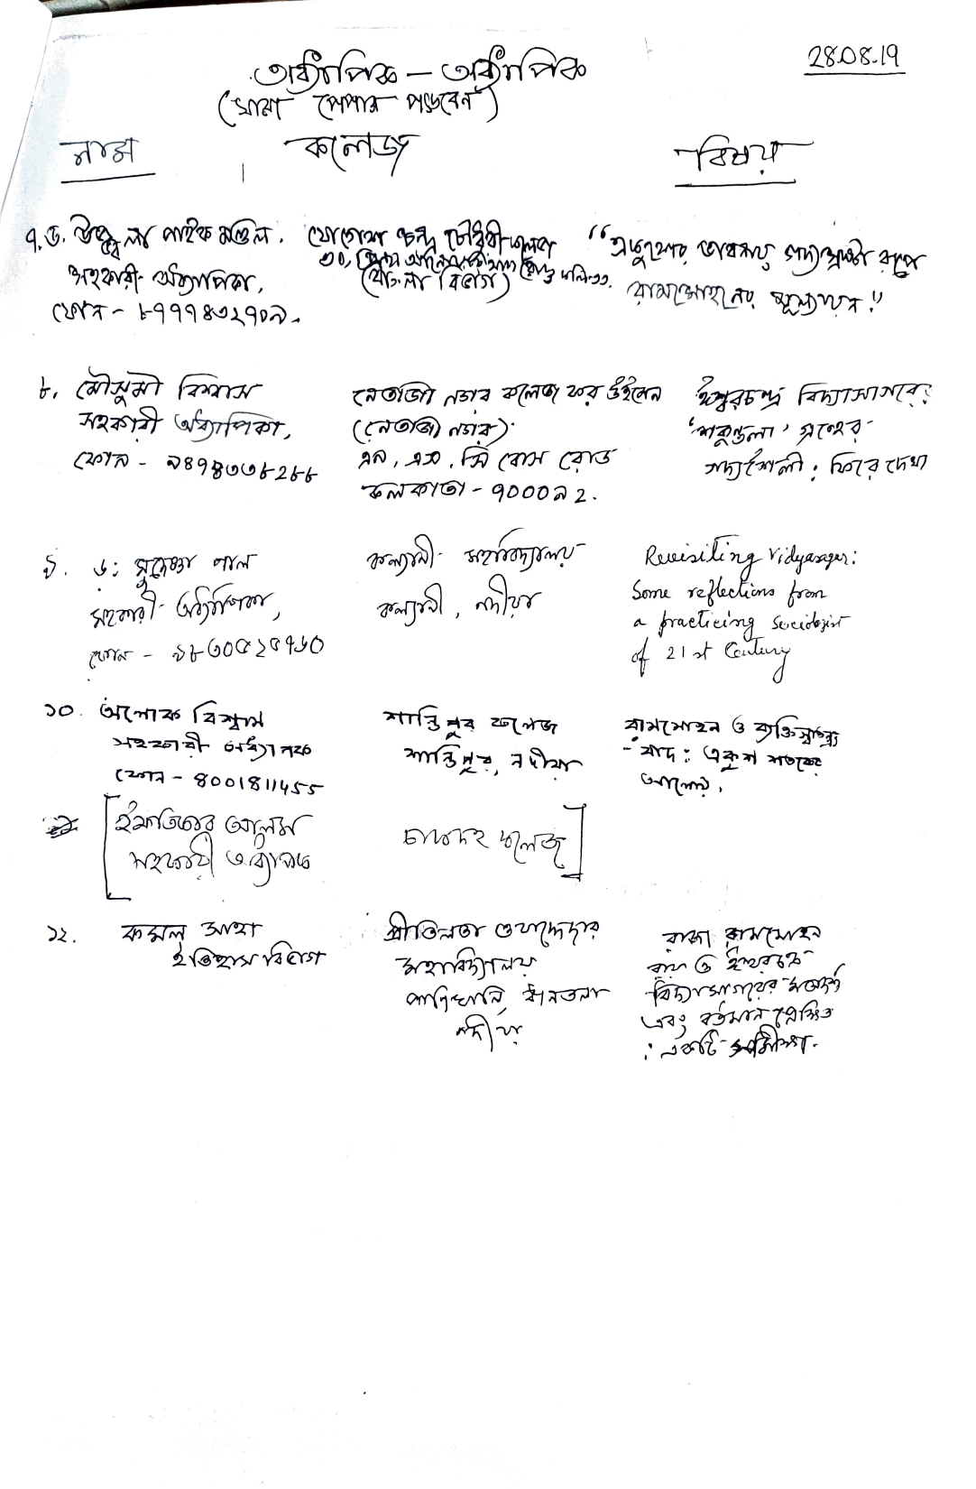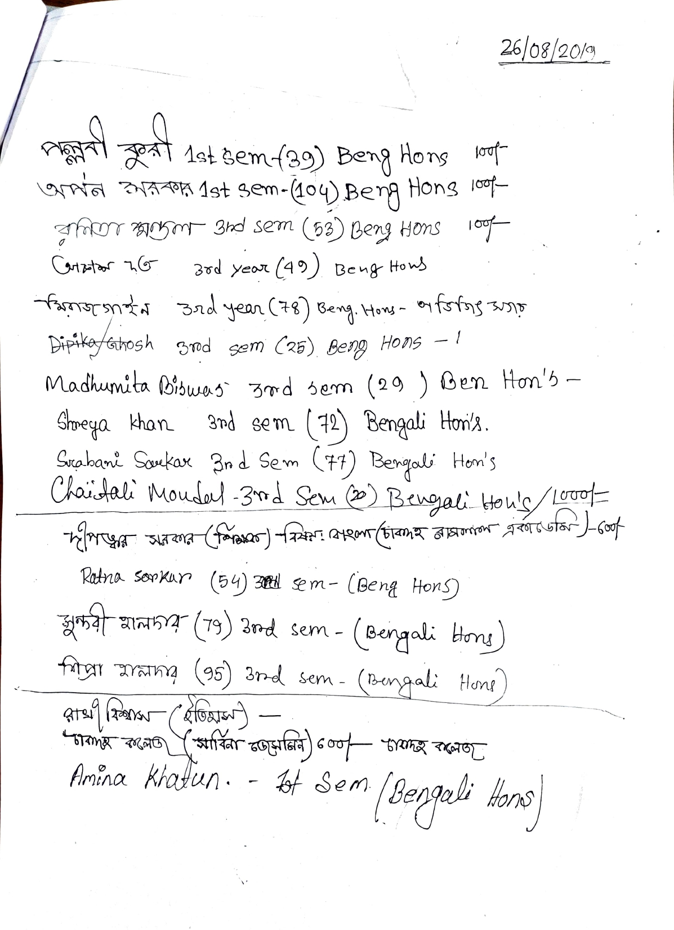

Relevant Web Link:

<https://www.facebook.com/photo/?fbid=332331931960776&set=pcb.332333015294001>